Beneficiary Name:  Beneficiary Address  Beneficiary Email:  Delivery Address: | Exchange Account:
CLAIM FORM
 | Amounts |  | Account Numbers

Kindness Credits
Conversion
Electricity

Gas
Water
Council Tax
Debt
Credit Charges

Organic Food Small / Medium / Large VEG
Organic Food Small /Medium /Large FRUIT
Olive Oil
Chocolate

Exchange Swap
(what are you offering in exchange)

Mortgage
Minister EMOVEN Robes
Oracle Services ( Teaching)

Electricity Meters
Gas Meters

Travel Costs

Minister Your Mind Ebook

Total KC

Total in slave tokens :

IBAN : GB42LOYD30944311256368 or 30-94-43 11256368 (RG SWAIN) this is our clearance account.

Please add Kindness Credit Account number and your own unique 4 digit code that you choose

Energy Exchange : How to use this form :
You add in the box above what you are requiring on a monthly / Yearly basis
Such as rent / clothing/ travel. This then goes as a claim against your account to create and release that amount of Kindness Credits converted into prepaid credit for those who you are doing exchanges with.
Converting someone else to Kindness Credits.
You simply create the party you wish to exchange with a proton email account and get them to send a request for a Kindness Credit Account to it with your KC account number on. This is pay it forward.

Then you :
You fill out the Kindness Credit Note as follows
1) the date
2) The amount in Kindness Credits
3) The thumbprint
4) The signature

You write, like you would on a cheque, Pay (KC account you want to credit ) From ( Your KC account ) In Kindness Credits

Issuing Kindness Credits into your community: How to:

You write the IBAN number on the back of the note and give that to someone instead of cash. They then send this to our KC clearance address with their IBAN number to have the credit sent to them or they use it to exchange with products from the site this is how we put the KC into the community. Very Simple
The address to send the notes to are : 125 The Suites Holme Street Halifax HX7 8AA

1) 2) 3)
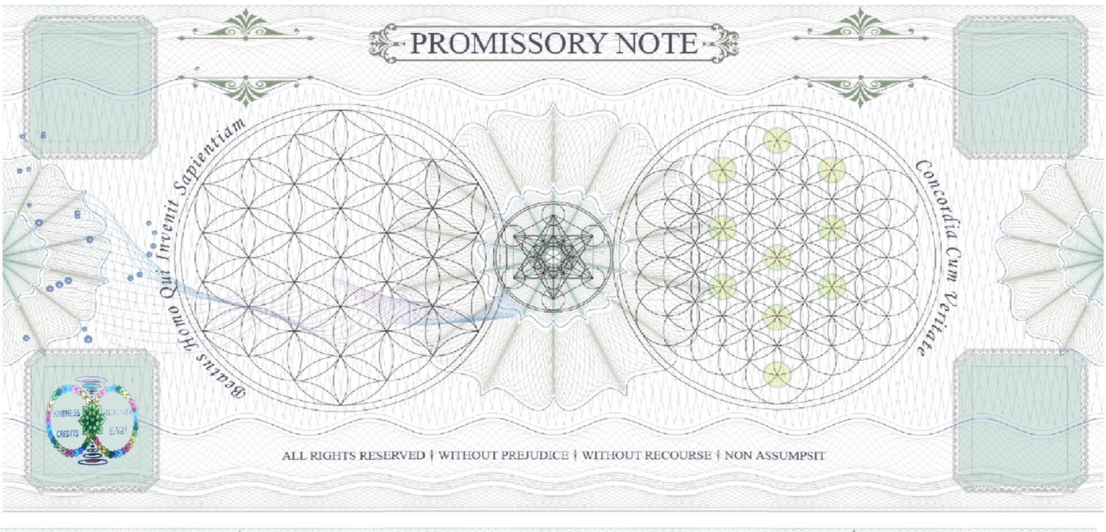
4)

