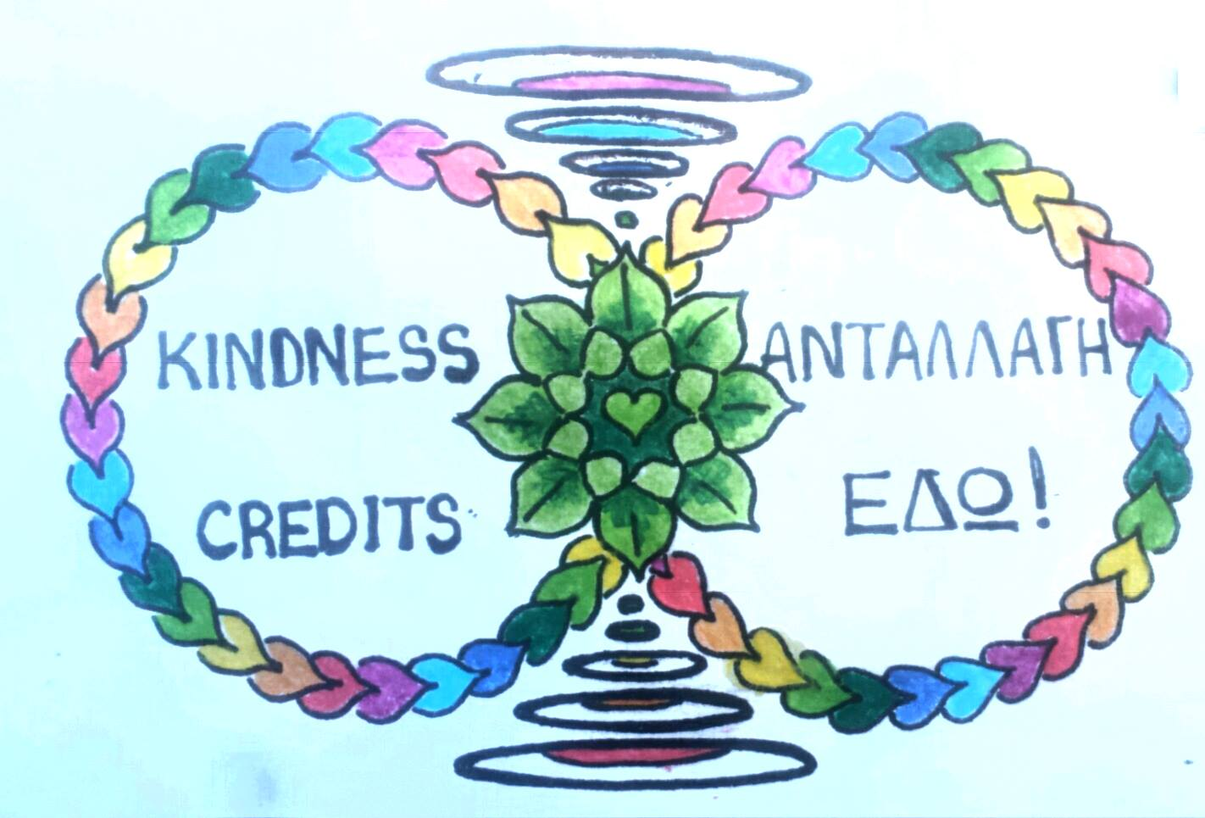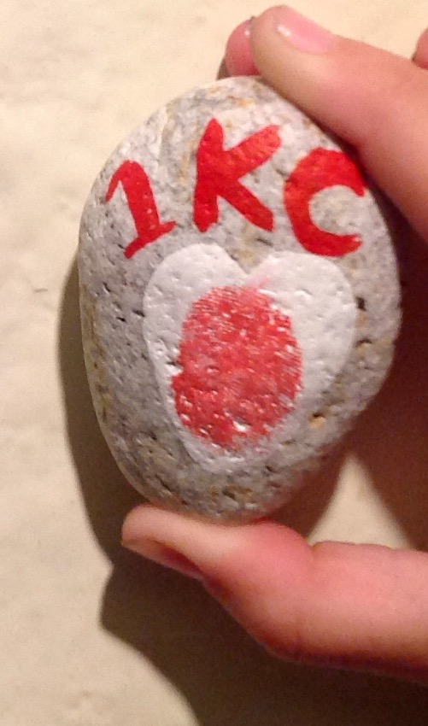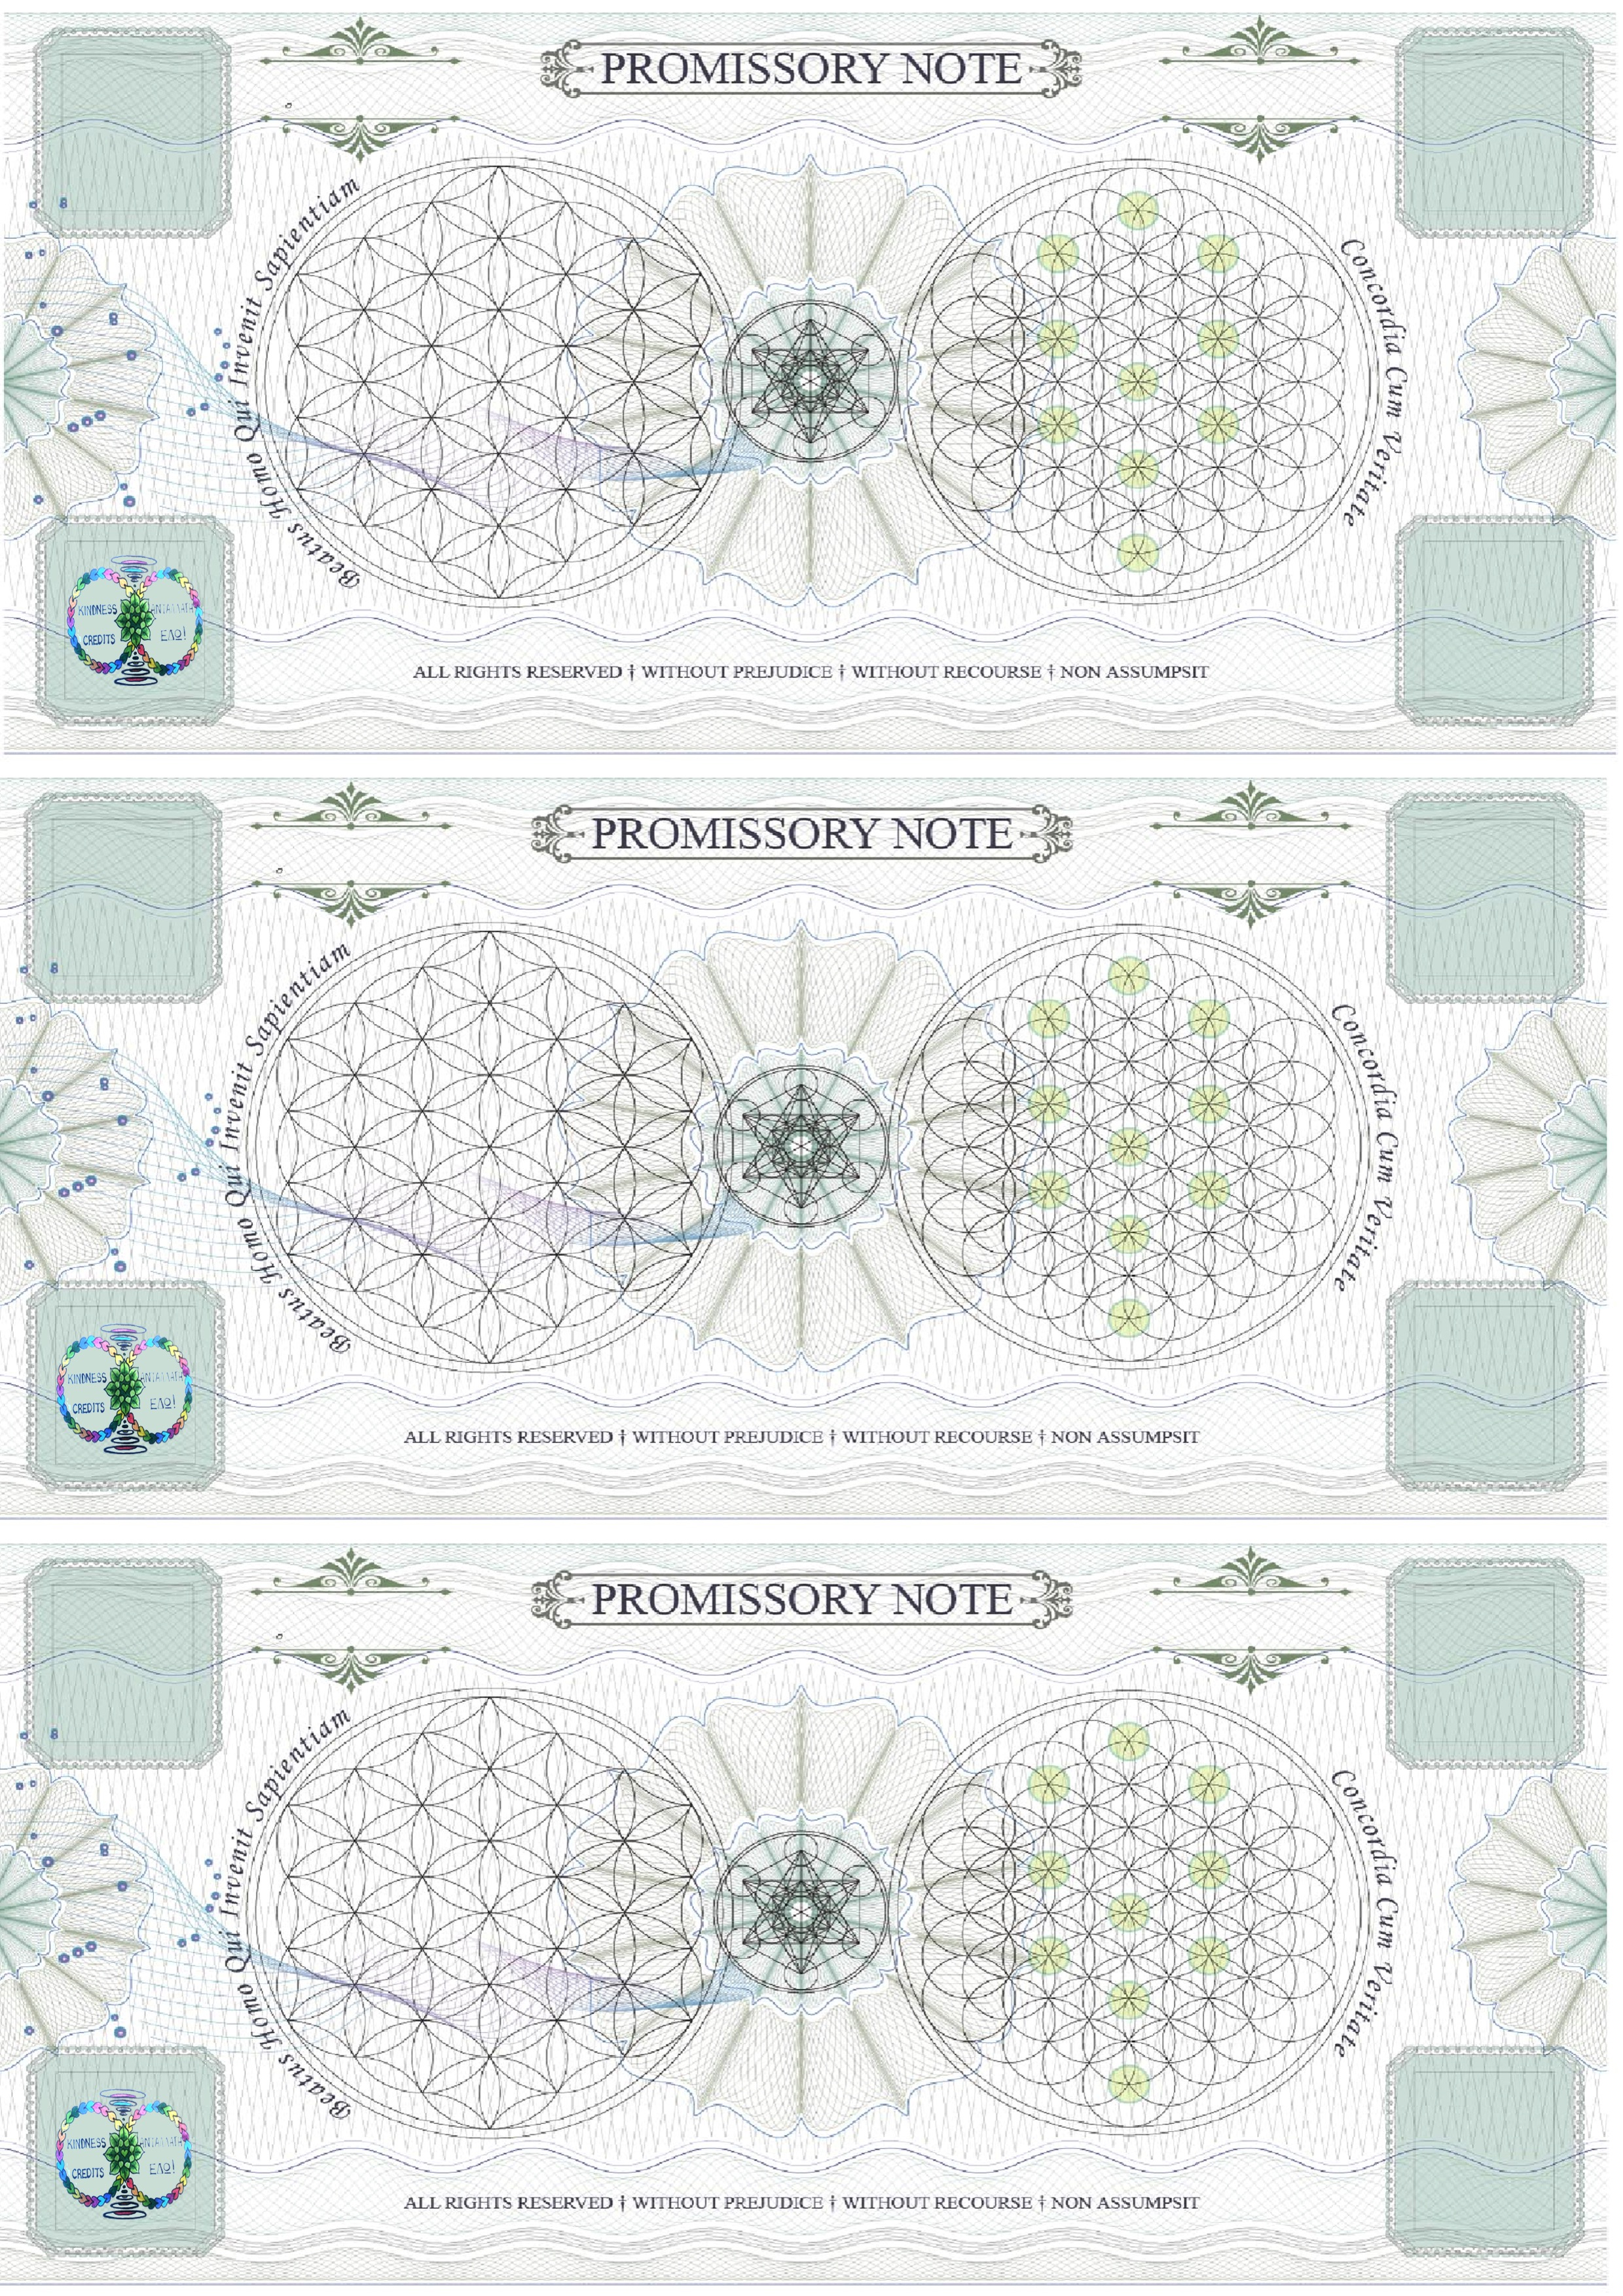

LOVE ROCKS

MAKE YOUR TIME AND ENERGY SPENT IN THE ISLAND OF KNOWLEDGE THE BEST “TIME “YOU EVER “SPENT”.

KINDNESS CREDITS

AS MENTIONED ON

TRIP ADVISOR OFFERS A COMPLETELY DIFFERENT STRUCTURE TO YOUR LIFE.

THE FUN STARTS HERE.

ENJOY OUR CULTURAL CENTRE WHERE YOU CAN LEARN HOW TO SET YOURSELF FREE FROM

**“THE DEBT SLAVE CULTURE “**

~**CULTIVATE** A NEW LIFE .

~MAKE EVRY DAY A ~HOLIDAY

~FREE OF CORPORATE SLAVERY

FIND OUT HOW

9.30 AM – 11PM EVERYDAY

1. TAKE KINDNESS CREDITS TO MINISTRY OF REMEDIES ~ IRENE PLATIA PYTHAGOREIO
2. COLLECT KINDNESS CREDIT ROCKS ALONG THE WAY
3. EXCHANGE THE NOTE AND THE ROCKS IN THE KINDNESS CREDIT BANK
4. OPEN A KINDNESS CREDIT ACCOUNT DISCHARGE ALL DEBT
5. GET UP TO 30% DISCOUNT IN ALL PARTICIPATING SHOPS WITH YOUR KINDNESS CREDIT CARD
6. SUPPORT THE LOCAL COMMUNITY TO SUPPORT YOU NATURALLY

🙜THE MINISTRY OF

REMEDIES🙜

AS YOU ENJOY YOUR HOLIDAY KEEP YOUR EYES OUT FOR THE LOVE ROCKS SCATTERED AROUND. IF YOU FIND THE KINDNESS CREDIT LOVE ROCKS YOU CAN EXCHANGE THEM FOR FREE ICE CREAM / ORGANIC COFFEE/ FRESH JUICE AT THE MINISTRY OF REMEDIES AND BEGIN ON YOUR TREASURE HUNT TRAIL.

🙞 🙜

**THE MINISTRY OF REMEDIES ~ PLATIA IRENE PYTHAGOREIO SAMOS**

**www.universallawcommunitytrust.com**

# Your Treasury Account Awaits

≈We have an alternative solution to slaving for a system that offers no Remedy. In our Ministry of Remedies in Irene Platia Pythagoreio you will find: Organic Coffee for the same as 50c (1 Kind of Kindness) ≈ A Taverna that only uses local and organic produce with 50% discount 1 Plate of the day with organic local wine – ½ Kindness Credit (4 E ) A debt settlement house (bank) where you can learn how to utilse your credit file without paying for using your own credit. ≈ A Money Exchange Service ~locating your Treasury Account through the Kindness Credit Treasure Hunt. By opening an Account with the notes attached here You receive your Kindness Credit Card which gives you unlimited credit and up to 30% discount in other participating outlets.

KINDNESS CREDITS is the local currency adopted by people of this community. It helps to support local producers and growers directly allowing for people to access natural organic food and natural remedies at a fraction of the cost when bought with non local currency.

It brings all the local people together to support one another and removes the leaking of energy into systems that do not return on our investment in them what they are obligated to.

The reason Kindness Credits exists is because we have all decided that we do not want to just supply our visitors and community with synthetic plastic food and produce and that we deserve better, Usually what is food and nature has a premium many people can not afford making it more profitable to persecute one another as everyone struggles to pay their cost of living. Using Kindness Credits helps you support yourself and your community free of slavery

\