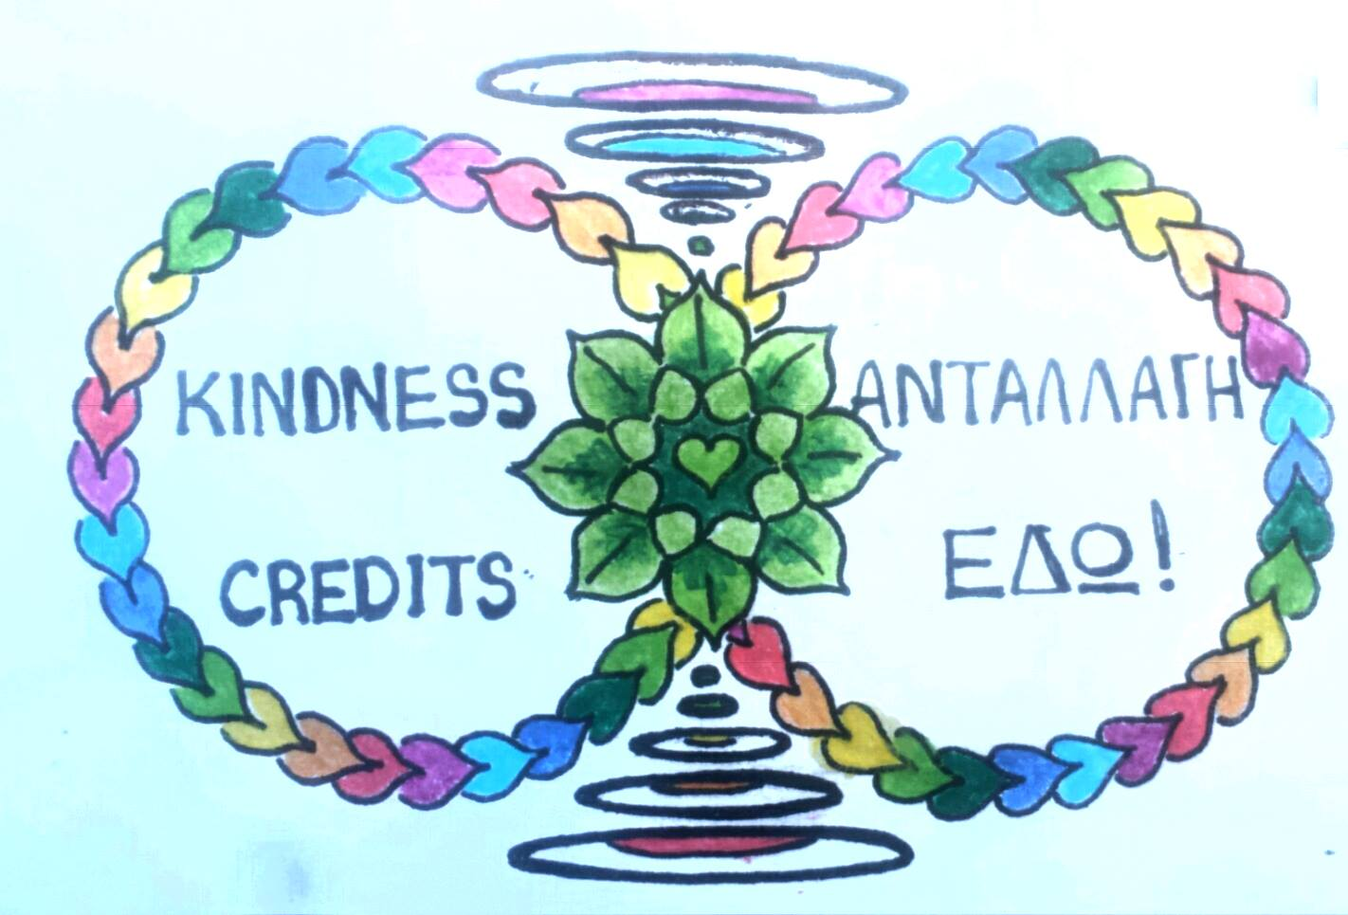

Your community is no longer accepting the treatment of you and themselves by Corporations and their greed. We refuse to stand by and watch another extermination of those in need.

**Kindness Credits** is a community run project that offers a restoration of people’s rights using The Law. We have perfected securitization of assets stolen from people like you and now want to restore your rights to them

Your community is no longer accepting the treatment of you and themselves by Corporations and their greed. We refuse to stand by and watch another extermination of those in need.

**Kindness Credits** is a community run project that offers a restoration of people’s rights using The Law. We have perfected securitization of assets stolen from people like you and now want to restore your rights to them

Your community is no longer accepting the treatment of you and themselves by Corporations and their greed. We refuse to stand by and watch another extermination of those in need.

**Kindness Credits** is a community run project that offers a restoration of people’s rights using The Law. We have perfected securitization of assets stolen from people like you and now want to restore your rights to them

Your community is no longer accepting the treatment of you and themselves by Corporations and their greed. We refuse to stand by and watch another extermination of those in need.

**Kindness Credits** is a community run project that offers a restoration of people’s rights using The Law. We have perfected securitization of assets stolen from people like you and now want to restore your rights to them

### Outside,

### please come and meet your Kindness Credit Converter Support Worker @

### Outside,

### please come and meet your Kindness Credit Converter Support Worker @

### Outside,

### please come and meet your Kindness Credit Converter Support Worker @

### Outside,

### please come and meet your Kindness Credit Converter Support Worker @

Tel: 07562455389 for more info visit www.universallawcommunitytrust.com

# Solutions : Housing : Food : Support: Protection

## Where?

## When?

## How?

### We are part of a large Trust operated by the people who have had enough of seeing terrorism of our community, ex professionals who have donated their time now to you repaying the debt they have caused you in our Kindness Credit Exchange

Tel: 07562455389 for more info visit www.universallawcommunitytrust.com

# Solutions : Housing : Food : Support: Protection

## Where?

## When?

## How?

### We are part of a large Trust operated by the people who have had enough of seeing terrorism of our community, ex professionals who have donated their time now to you repaying the debt they have caused you in our Kindness Credit Exchange

### We are part of a large Trust operated by the people who have had enough of seeing terrorism of our community, ex professionals who have donated their time now to you repaying the debt they have caused you in our Kindness Credit Exchange

## How?

## When?

## Where?

# Solutions : Housing : Food : Support: Protection

Tel: 07562455389 for more info visit www.universallawcommunitytrust.com

Tel: 07562455389 for more info visit www.universallawcommunitytrust.com

# Solutions : Housing : Food : Support: Protection

## Where?

## When?

## How?

### We are part of a large Trust operated by the people who have had enough of seeing terrorism of our community, ex professionals who have donated their time now to you repaying the debt they have caused you in our Kindness Credit Exchange